Lesson 6: Algebraic Expressions—The Distributive Property

Classwork

Exercises

1. Using the numbers $1$, $2$, $3$, $4$ only once and the operations $+$ or $×$ as many times as you like, write an expression that evaluates to $16$.  Use this expression and any combination of those symbols as many times as you like to write an expression that evaluates to $816$.
2. Define the rules of a game as follows:
   1. Begin by choosing an initial set of symbols, variable or numeric, as a starting set of expressions.
   2. Generate more expressions by placing any previously created expressions into the blanks of the addition operator: $______+_______$.
3. Roma says that collecting like terms can be seen as an application of the distributive property. Is writing $x+x=2x$ an application of the distributive property?
4. Leela is convinced that ${(a+b)}^{2}=a^{2}+b^{2}$. Do you think she is right? Use a picture to illustrate your reasoning.
5. Draw a picture to represent the expression $\left(a+b+1\right)×\left(b+1\right)$.
6. Draw a picture to represent the expression $\left(a+b)×(c+d)×(e+f+g\right).$

**A Key Belief of Arithmetic**

**The distributive property**: If $a$, $b$, and $c$ are real numbers, then $a\left(b+c\right)=ab+ac$.

Lesson Summary

The distributive property represents a key belief about the arithmetic of real numbers. This property can be applied to algebraic expressions using variables that represent real numbers.

Problem Set

1. Insert parentheses to make each statement true.
$2+3×4^{2}+1=81$

$2+3×4^{2}+1=85$

$2+3×4^{2}+1=51$

$2+3×4^{2}+1=53$

2. Using starting symbols of $w$, $q$, $2$, and $-2$, which of the following expressions will NOT appear when following the rules of the game played in Exercise 3?
$7w+3q+(-2)$

$q-2$

$w-q$

$2w+6$

$-2w+2$

3. Luke wants to play the $4$-number game with the numbers $1$, $2$, $3$, and $4$ and the operations of addition, multiplication, AND subtraction.

Leoni responds, “Or we just could play the $4$-number game with just the operations of addition and multiplication, but now with the numbers $-1$, $-2$, $-3$, $-4$, $1$, $2$, $3$, and $4$ instead.”

What observation is Leoni trying to point out to Luke?

1. Consider the expression: $\left(x+3\right)∙\left(y+1\right)∙(x+2)$.
   1. Draw a picture to represent the expression.
   2. Write an equivalent expression by applying the distributive property.
   3. 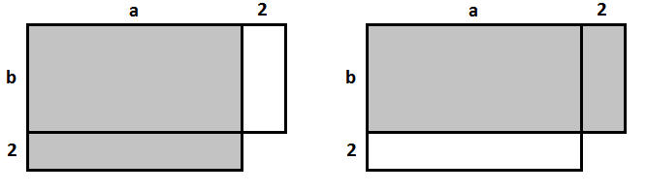Given that $a>b$, which of the shaded regions is larger and why?
   4. Consider the expressions $851×29$ and $849×31$. Which would result in a larger product? Use a diagram to demonstrate your result.
2. Consider the following diagram.

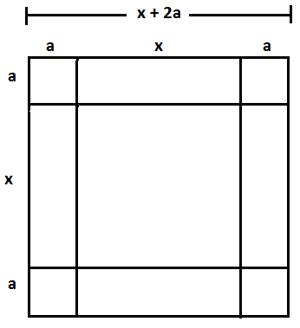

Edna looked at the diagram and then highlighted the four small rectangles shown and concluded:

.

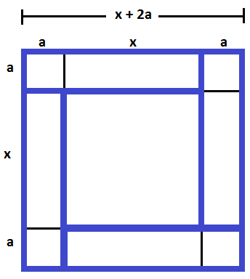

* 1. Michael, when he saw the picture, highlighted four rectangles and concluded:

${(x+2a)}^{2}=x^{2}+2ax+2a(x+2a)$.

Which four rectangles and one square did he highlight?

* 1. Jill, when she saw the picture, highlighted eight rectangles and squares (not including the square in the middle) to conclude:

${(x+2a)}^{2}=x^{2}+4ax+4a^{2}$.

Which eight rectangles and squares did she highlight?

* 1. When Fatima saw the picture, she concluded:

${(x+2a)}^{2}=x^{2}+4a\left(x+2a\right)-4a^{2}$.

She claims she highlighted just four rectangles to conclude this. Identify the four rectangles she highlighted, and explain how using them she arrived at the expression .

* 1. Is each student's technique correct? Explain why or why not.